Thank you for the choice in the Generic Overdrive Pedal!

Before using this unit, please read the section titled: “Safety Instructions.” These sections include proper care and general safety of the unit.

**Safety Instructions**

* Do not expose unit or its’ AC power to moisture to prevent damage, fire, or electric shock.
* Do not drip liquids on the unit.
* Unplug the power adapter before cleaning the unit with a damp cloth.
* Use care when adjusting the volume. Amplifiers and headphones may cause temporary or permanent hearing damage.
* Always turn down volume and turn off power on all devices before making connections.

**Features**

**Level**

Adjusts overall volume level.

**Drive**

Controls the amount of distortion.

**Input Jack**

Suitable for electric guitar, bass, and other instruments.

**Output Jack**

Connects to the amplifier or the next pedal in the chain.

**Additional gear**

You will need two instrument cables for one pedal. Two long cables (10 ft min.) are recommended if you desire to have the pedal positioned away from the amplifier. Additional instrument cables will be needed for each pedal added to the rig.

**Let’s Begin**

Plug your electric guitar into the input jack of the pedal. Then plug the second cable into the output jack of the pedal. The second cable will connect to the input jack of the amplifier. Depending on your model, the input jack will be on the front, top, or back of the amplifier.

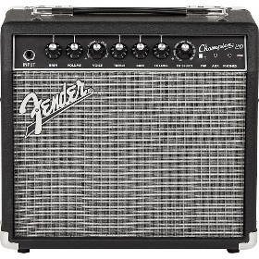

**Changing the Batteries**

The red led light on the front of the battery door will illuminate when battery voltage drops, indicating that the battery will need to be changed soon.

**Specifications**

* Input Impedance: 575k ohm
* Output Impedance: 9k ohm
* Power Consumption: 110mA
* Power Requirements: 9-Volt Battery or Center Negative AC Adapter (not included)
* Weight: 0.9lbs (0.41kg)